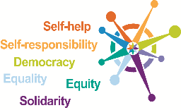
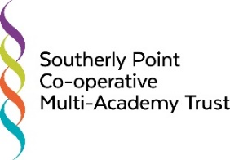

Southerly Point Co-operative Multi-Academy Trust
Finance and Resources Committee Meeting
Thursday 10th December 2019, from 6.00pm,
Online meeting due to the Covid 19 pandemic

Agenda

- Welcome and Declarations of Pecuniary Interests
- Audit Report [Alison Oliver / SPi] and Annual Accounts
- Internal Audit
- Management Accounts – final 2019/20 and October 2020/21 [SPi]
- Confirm Pupil Census numbers re. Funding 2021-2022 [SPi]
- Catering Analysis [SPi]
- SCA and DFC Report [SPi]
- Scheme of Financial Delegation [SPi]
- Policies - not applicable on this occasion
- Risk Register Review [DBr]
- Minutes and Matters Arising [DBr]
- Any Other Business
- Dates and times of future meetings

