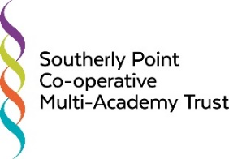

Southerly Point Co-operative Multi-Academy Trust
Board Meeting
Thursday 22nd October 2020, from 6.00pm,
Online Meeting due to Covid 19

Agenda

Item | Purpose / Action | Timing [mins] | Who
Welcome and Declarations of Pecuniary interests | Review |  | Chair
Minutes and Matters Arising | Review | 15 | DBr
Finance and Resources / Standards / CSAW Committee Minutes | Ratification required | 5 | KTe
Local Governing Bodies:  - Matters Arising from LGB Meetings  - Governor Training Attendance  - Trustee feedback from LGB Meetings  - Forums / Forum Member  - Pen Portraits of Prospective Governors | Receive and discuss  Receive  Receive and discuss  Receive and discuss  Approval required | 15 | DBr
EL Report and Updates | Information: Pre-read and come with questions / challenge | 45 | DBr
Reasons to Celebrate and Areas of Challenge | Identify and discuss | 5 | KTh
IT Update | Information and Discussion | 10 | DBr
Pay Reviews | Discussion and Decision | 10 | DBr
Policies | Ratification required | 15 | DBr
Health and Safety Update | Information and discussion | 10 | AHo

Any Other Business  - Pay Review Panel;  - Modern Slavery Statement – ratification required;  - ESFA letter to Academy Trust Accounting Officers, July 2020;  - Code of Conduct for Trustees;  The Essential Trustee;  KCSIE 2020;  DfE’s ‘Academy Trust Governance – Structures and Role Descriptors’  - Training for Trustees  - Reappointment of Trustees  - DBS checks  - Note thanks to RLa and LSc | Information | 10 | Chair
Dates and times of future meetings | Information |  | Chair

