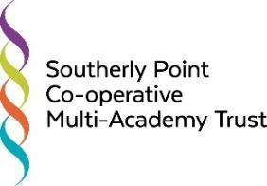

Southerly Point Co-operative Multi-Academy Trust
Standards Committee Meeting
Thursday 11th June 2020, from 6.00pm,
Online meeting due to the Covid 19 pandemic

Agenda

Item | Purpose / Action | Timing [mins] | Who
Welcome and Declarations of Pecuniary interests | Review |  | Chair
Minutes and Matters Arising | Review | 10 | DBr
Covid 19 Provision for Learning:  Online engagement  In school attendance  Disadvantaged - arrangements and impact  SEND provision | Information and scrutiny [see shared Google documents: Levels of Engagement & Pupil Numbers] | 20 | DBr
Exams and Assessment Update | Information | 10 | DBr
Performance and Progress Data:  Overview | Information | 10 | RLa  DBr
Behaviour and Attendance Data - update on current provisions | Information | 10 | DBr
Updates to the Risk Register as per Covid 19 action plans - School Level Risk Registers | Discussion/ recommendations | 10 | DBr
Any Other Business | Information
Dates and times of future meetings | Information

