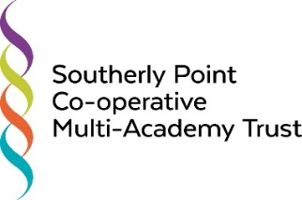

Enabling Excellence Together

Southerly Point Co-operative Multi-Academy Trust is comprised of 15 schools situated around Helston and the Lizard – the most Southerly part of Cornwall.
Our schools are:

Breage C of E Primary
Crowan Primary
Cury C of E Primary
Garras and Sithney Federation
Godolphin Primary
Halwin Primary
Helston Community College
Landewednack Primary
Mullion Primary
Mullion Secondary
Parc Eglos Primary
Porthleven Primary
Trannack Primary
Wendron C of E Primary

Our Beliefs:
We are a Co-operative Multi-Academy Trust. We believe in working together so that everyone benefits.
Our work is underpinned by the Co-operative values:
Self-help, Self-responsibility, Equity, Equality, Democracy, Solidarity, Social responsibility, Openness, Honesty and Caring for others.
These values inform everything that we do.
We have one simple objective: To enable excellence together
As a Trust, our role is to enable every school to become outstanding through school to school challenge, support and development and the provision of excellent support services, allowing headteachers to focus on the main thing: our children. Each child in every school will always come first.
Our Background:
The schools in the Trust have a long history of working together – those living and working in the area may well remember SKILL, the South Kerrier Initiative for Linking Learning. Through this, schools worked together to provide sporting opportunities and curriculum enrichment activities. In 2012, the schools joined together to form the Helston and Lizard Peninsula Educational Trust, a Co-operative Foundation Trust. This work led to an even closer working relationship with shared procurement via a Trust Business Manager, shared performance data, school to school reviews and staff training events. The next step for us was to ensure the longevity of this working relationship and to deepen its effectiveness by becoming a Co-operative Multi-Academy Trust.
The Southerly Point Co-operative Multi-Academy Trust opened officially on 1st June 2017 so these are exciting times as we are all work hard to realise our aim. We look forward to you joining us on the journey.

